From 1967 to 1991 Johnson collaborated with John Burgee. This was by far Johnson's most productive period — certainly by the measure of scale — he became known at this time as builder of iconic office towers, including Minneapolis's IDS Tower. That building's distinctive stepbacks (called "zogs" by the architect) created an appearance that has since become one of Minneapolis's trademarks and the crown jewel of its skyline. In 1980, the Crystal Cathedral was completed for Rev. Robert H. Schuller's famed megachurch, which became a Southern California landmark.
The AT&T Building in Manhattan, now the Sony Building, was completed in 1984 and was immediately controversial for its neo-Georgian pediment (Chippendale top). At the time, it was seen as provocation on a grand scale: crowning a Manhattan skyscraper with a shape echoing a historical wardrobe top defied every precept of the modernist aesthetic: historical pattern had been effectively outlawed among architects for years. In retrospect other critics have seen the AT&T Building as the first Postmodernist statement, necessary in the context of modernism's aesthetic cul-de-sac. In 1987, Johnson was awarded an honorary doctoral degree from the University of Houston. The institution's Hines College of Architecture is also housed in one of Johnson's buildings.
Johnson's publicly held archive, including architectural drawings, project records, and other papers up until 1964 are held by the Drawings and Archives Department of Avery Architectural and Fine Arts Library at Columbia University, the Getty, and the Museum of Modern Art.

Philip Cortelyou Johnson
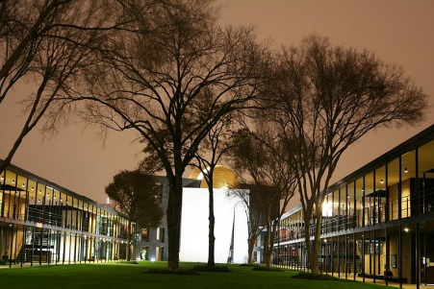  Chapel of St. Basil on the Academic Mall at the University of St. Thomas in Houston, Texas. | 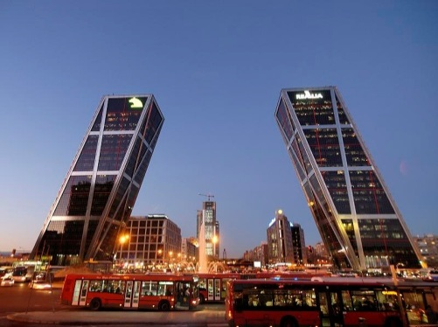  Puerta de Europa in Madrid | 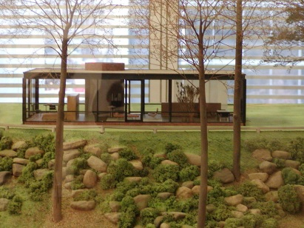  A model of the Glass House on display at the Museum of Modern Art in New York City
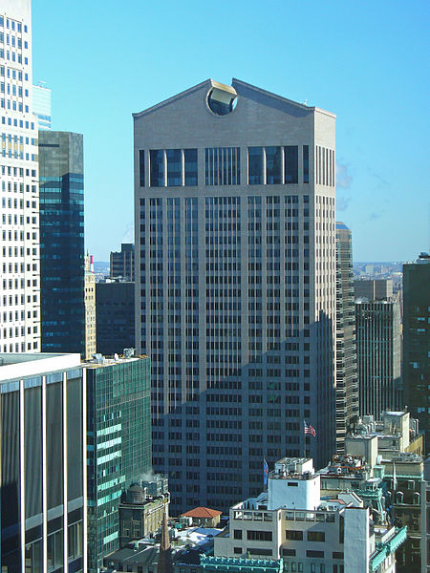  The postmodern AT&T Building, now the Sony Building | 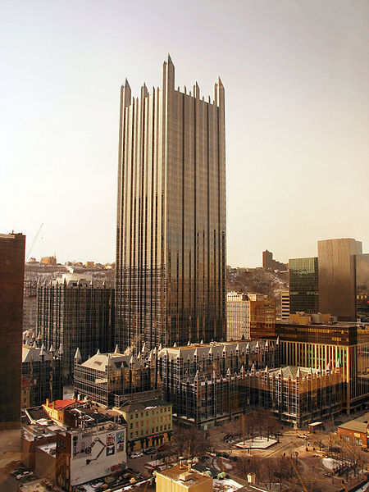  PPG Place in Pittsburgh, Pennsylvania, in 2007. | 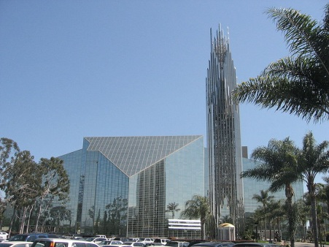  The Crystal Cathedral, Garden Grove, California in 2007.

- CESAR PELLI
(born October 12, 1926)



César Pelli is an Argentine American architect known for designing some of the world's tallest buildings and other major urban landmarks. In 1991, the American Institute of Architects (AIA) listed Pelli among the ten most influential living American architects. His many awards include the 1995 AIA Gold Medal which recognizes a body of work of lasting influence on the theory and practice of architecture. Perhaps his most famous work are the Petronas Twin Towers, which were for a time the world's tallest buildings. He also designed the World Financial Center complex in downtown Manhattan, next to the since-fallen World Trade Center.
After studying architecture at the Universidad Nacional de Tucumán, Pelli completed his studies at the School of Architecture at the University of Illinois at Urbana-Champaign. He started his career in the New Haven offices of architect Eero Saarinen.
He emigrated to the United States in 1952 and became a naturalized U.S. citizen in 1964. He married Diana Balmori, a renowned landscape and urban designer. They have two children: Denis, a neurobiologist and Professor of Psychology and Neural Science at New York University and Rafael, also a renowned architect.
Pelli served as dean of the School of Architecture at Yale University from 1977 to 1984. His firm employs about 100 architects, designers, and support staff in New Haven, Connecticut.
Awards and honors: On May 26, 2008, Yale University bestowed an honorary Doctor of Arts degree to Pelli for his work in Architecture.
He received the The Lynn S. Beedle Lifetime Achievement Award from the Council on Tall Buildings and Urban Habitat in 2008 to honor his work in the field of tall buildings.

Cesar Pelli
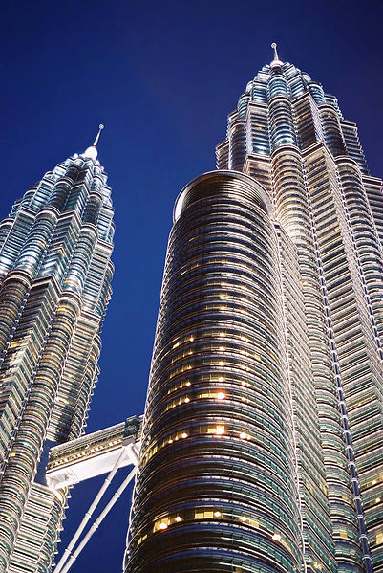  Pelli and Mahathir Mohamad's Petronas Twin Tower, 1998 | 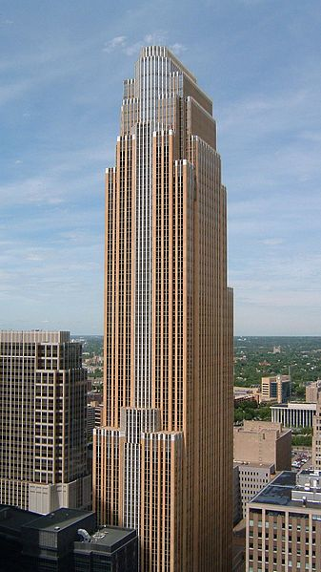  Pelli's Wells Fargo Center, Minneapolis, Minnesota, 1989. Jon Davis | 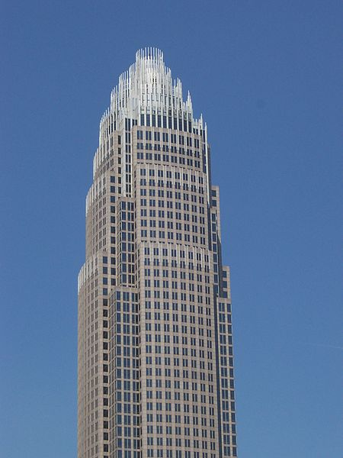  Bank of America Corporate Center, located in the center of uptown Charlotte, North Carolina, 1992
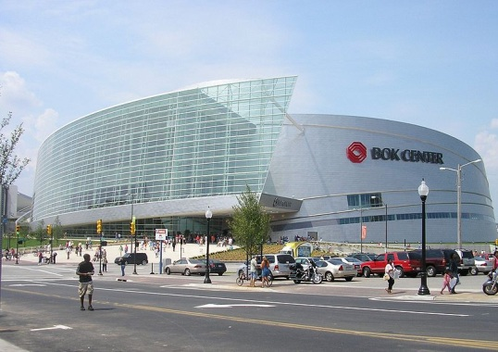  BOK Center in Tulsa, Oklahoma. | 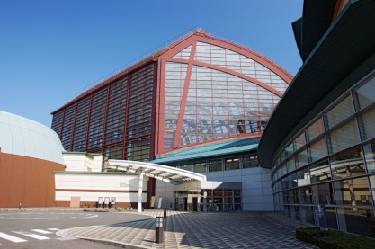  Kurayoshi Park Square in Kurayoshi, Japan | 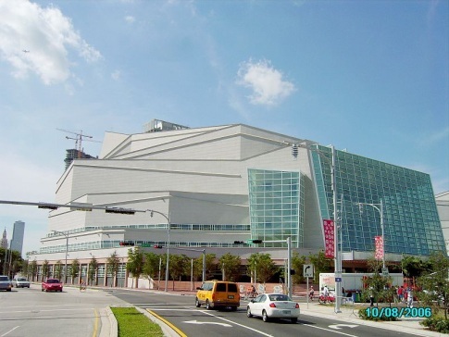  Adrienne Arsht Center for the Performing Arts in Miami, Florida.

